Matching & checking algorithms:

First of all, Make a array to hold three index of all possible cases.

Make a looping start,

set a default false value for status of matching and create a move object for each time.

Then we can go though each case by using for loop.

In each case, check whether the number are on the the same level.

Then use move object to help me check the numbers are matched or not.

Move object checks whether the numbers are the same or are in sequeunce.

If the numbers are valid,

move will add the numbers into its non-duplicate data set which stores the numbers that will be removed.

The move object returns a boolean value to indicate the status for matching.

endif

If the status of matching is true, this round involves number matching.

Count the numbers of removal using move object and use the couting result to help me do calculation for the mark.

Set the mark for the move object.

Push the move object into stack and add the mark to the score.

endif

continue the looping while the status of matching is true(involve matching).

Undo algorithm:

During the game flow, i only push two types of item into the undo stack.

The items are Move object and the user choice of position.

First , I pop out an item from the undo stack and check its type.

While the poped out item is a move,

Use the move object to get the removed number.

The removed number is an integer array which stores the number removed during matching .

go though the removed number one by one,

if the element is not Move.DEFAULT_VALUE

push the elemnt into the stack with specified index.

get the mark from the move and deduct the score by it .

endif

endWhile

The integer poped out ends the while loop.

It is the user’s choice for position.

push back the integer (user choice) to the the heading of queue.

Save structure:  
I use Object output directly save the object of game and its related object into a file.

When I load it, the object reference of Game is assigned once again.

Since the testing content is very long:  
Here is the table

|  |  |
| --- | --- |
| Matching,combo | 1-4 |
| Undo | 4-7 |
| GameOver | 7-25 |
| GUI save&load | 26 - 37 |

Console output testing:

Test Matching,combo and undo

Jasonteki-MacBook-Air:bin jason$ java NumberMatchingGame numbers.txt

### 000

### 000

### 000

Current score is :0

Next three numbers area : [ 1 2 3 ]

Which position (1-9,0 to undo)? 1

1## 100

### 000

### 000

Current score is :0

Next three numbers area : [ 2 3 4 ]

Which position (1-9,0 to undo)? 2

12# 110

### 000

### 000

Current score is :0

Next three numbers area : [ 3 4 6 ]

Which position (1-9,0 to undo)? 3

+30

### 000

### 000

### 000

Current score is :30

Next three numbers area : [ 4 6 6 ]

Which position (1-9,0 to undo)? 1

4## 100

### 000

### 000

Current score is :30

Next three numbers area : [ 6 6 7 ]

Which position (1-9,0 to undo)? 3

4#6 101

### 000

### 000

Current score is :30

Next three numbers area : [ 6 7 5 ]

Which position (1-9,0 to undo)? 5

4#6 101

#6# 010

### 000

Current score is :30

Next three numbers area : [ 7 5 1 ]

Which position (1-9,0 to undo)? 8

4#6 101

#6# 010

#7# 010

Current score is :30

Next three numbers area : [ 5 1 3 ]

Which position (1-9,0 to undo)? 2

+50

### 000

### 000

### 000

Current score is :80

Next three numbers area : [ 1 3 1 ]

Which position (1-9,0 to undo)? 1

1## 100

### 000

### 000

Current score is :80

Next three numbers area : [ 3 1 3 ]

Which position (1-9,0 to undo)? 3

1#3 101

### 000

### 000

Current score is :80

Next three numbers area : [ 1 3 3 ]

Which position (1-9,0 to undo)? 7

1#3 101

### 000

1## 100

Current score is :80

Next three numbers area : [ 3 3 1 ]

Which position (1-9,0 to undo)? 9

1#3 101

### 000

1#3 101

Current score is :80

Next three numbers area : [ 3 1 2 ]

Which position (1-9,0 to undo)? 4

1#3 101

3## 100

1#3 101

Current score is :80

Next three numbers area : [ 1 2 4 ]

Which position (1-9,0 to undo)? 6

1#3 101

3#1 101

1#3 101

Current score is :80

Next three numbers area : [ 2 4 5 ]

Which position (1-9,0 to undo)? 5

+70

### 000

### 000

### 000

Current score is :150

Next three numbers area : [ 4 5 3 ]

Which position (1-9,0 to undo)? 5

### 000

#4# 010

### 000

Current score is :150

Next three numbers area : [ 5 3 5 ]

Which position (1-9,0 to undo)? 5

### 000

#5# 020

### 000

Current score is :150

Next three numbers area : [ 3 5 6 ]

Which position (1-9,0 to undo)? 4

### 000

35# 120

### 000

Current score is :150

Next three numbers area : [ 5 6 7 ]

Which position (1-9,0 to undo)? 6

### 000

355 121

### 000

Current score is :150

Next three numbers area : [ 6 7 7 ]

Which position (1-9,0 to undo)? 4

### 000

655 221

### 000

Current score is :150

Next three numbers area : [ 7 7 6 ]

Which position (1-9,0 to undo)? 6

+30

2 Combo!! +90

### 000

### 000

### 000

Current score is :270

Next three numbers area : [ 7 6 7 ]

Which position (1-9,0 to undo)? 0

### 000

655 221

### 000

Current score is :150

Next three numbers area : [ 7 7 6 ]

Which position (1-9,0 to undo)? 0

### 000

355 121

### 000

Current score is :150

Next three numbers area : [ 6 7 7 ]

Which position (1-9,0 to undo)? 0

### 000

35# 120

### 000

Current score is :150

Next three numbers area : [ 5 6 7 ]

Which position (1-9,0 to undo)? 0

### 000

#5# 020

### 000

Current score is :150

Next three numbers area : [ 3 5 6 ]

Which position (1-9,0 to undo)? 0

### 000

#4# 010

### 000

Current score is :150

Next three numbers area : [ 5 3 5 ]

Which position (1-9,0 to undo)? 0

### 000

### 000

### 000

Current score is :150

Next three numbers area : [ 4 5 3 ]

Which position (1-9,0 to undo)? 0

1#3 101

3#1 101

1#3 101

Current score is :80

Next three numbers area : [ 2 4 5 ]

Which position (1-9,0 to undo)? 0

1#3 101

3## 100

1#3 101

Current score is :80

Next three numbers area : [ 1 2 4 ]

Which position (1-9,0 to undo)? 0

1#3 101

### 000

1#3 101

Current score is :80

Next three numbers area : [ 3 1 2 ]

Which position (1-9,0 to undo)? 0

1#3 101

### 000

1## 100

Current score is :80

Next three numbers area : [ 3 3 1 ]

Which position (1-9,0 to undo)? 0

1#3 101

### 000

### 000

Current score is :80

Next three numbers area : [ 1 3 3 ]

Which position (1-9,0 to undo)? 0

1## 100

### 000

### 000

Current score is :80

Next three numbers area : [ 3 1 3 ]

Which position (1-9,0 to undo)? 0

### 000

### 000

### 000

Current score is :80

Next three numbers area : [ 1 3 1 ]

Which position (1-9,0 to undo)? 0

4#6 101

#6# 010

#7# 010

Current score is :30

Next three numbers area : [ 5 1 3 ]

Which position (1-9,0 to undo)? 0

4#6 101

#6# 010

### 000

Current score is :30

Next three numbers area : [ 7 5 1 ]

Which position (1-9,0 to undo)? 0

4#6 101

### 000

### 000

Current score is :30

Next three numbers area : [ 6 7 5 ]

Which position (1-9,0 to undo)? 0

4## 100

### 000

### 000

Current score is :30

Next three numbers area : [ 6 6 7 ]

Which position (1-9,0 to undo)? 0

### 000

### 000

### 000

Current score is :30

Next three numbers area : [ 4 6 6 ]

Which position (1-9,0 to undo)? 0

12# 110

### 000

### 000

Current score is :0

Next three numbers area : [ 3 4 6 ]

Which position (1-9,0 to undo)? 0

1## 100

### 000

### 000

Current score is :0

Next three numbers area : [ 2 3 4 ]

Which position (1-9,0 to undo)? 0

### 000

### 000

### 000

Current score is :0

Next three numbers area : [ 1 2 3 ]

Which position (1-9,0 to undo)?

Jasonteki-MacBook-Air:bin jason$ java NumberMatchingGame numbers.txt

### 000

### 000

### 000

Current score is :0

Next three numbers area : [ 1 2 3 ]

Which position (1-9,0 to undo)? 1

1## 100

### 000

### 000

Current score is :0

Next three numbers area : [ 2 3 4 ]

Which position (1-9,0 to undo)? 2

12# 110

### 000

### 000

Current score is :0

Next three numbers area : [ 3 4 6 ]

Which position (1-9,0 to undo)? 3

+30

### 000

### 000

### 000

Current score is :30

Next three numbers area : [ 4 6 6 ]

Which position (1-9,0 to undo)? 1

4## 100

### 000

### 000

Current score is :30

Next three numbers area : [ 6 6 7 ]

Which position (1-9,0 to undo)? 3

4#6 101

### 000

### 000

Current score is :30

Next three numbers area : [ 6 7 5 ]

Which position (1-9,0 to undo)? 5

4#6 101

#6# 010

### 000

Current score is :30

Next three numbers area : [ 7 5 1 ]

Which position (1-9,0 to undo)? 8

4#6 101

#6# 010

#7# 010

Current score is :30

Next three numbers area : [ 5 1 3 ]

Which position (1-9,0 to undo)? 2

+50

### 000

### 000

### 000

Current score is :80

Next three numbers area : [ 1 3 1 ]

Which position (1-9,0 to undo)? 1

1## 100

### 000

### 000

Current score is :80

Next three numbers area : [ 3 1 3 ]

Which position (1-9,0 to undo)? 3

1#3 101

### 000

### 000

Current score is :80

Next three numbers area : [ 1 3 3 ]

Which position (1-9,0 to undo)? 7

1#3 101

### 000

1## 100

Current score is :80

Next three numbers area : [ 3 3 1 ]

Which position (1-9,0 to undo)? 9

1#3 101

### 000

1#3 101

Current score is :80

Next three numbers area : [ 3 1 2 ]

Which position (1-9,0 to undo)? 4

1#3 101

3## 100

1#3 101

Current score is :80

Next three numbers area : [ 1 2 4 ]

Which position (1-9,0 to undo)? 6

1#3 101

3#1 101

1#3 101

Current score is :80

Next three numbers area : [ 2 4 5 ]

Which position (1-9,0 to undo)? 5

+70

### 000

### 000

### 000

Current score is :150

Next three numbers area : [ 4 5 3 ]

Which position (1-9,0 to undo)? 5

### 000

#4# 010

### 000

Current score is :150

Next three numbers area : [ 5 3 5 ]

Which position (1-9,0 to undo)? 5

### 000

#5# 020

### 000

Current score is :150

Next three numbers area : [ 3 5 6 ]

Which position (1-9,0 to undo)? 4

### 000

35# 120

### 000

Current score is :150

Next three numbers area : [ 5 6 7 ]

Which position (1-9,0 to undo)? 6

### 000

355 121

### 000

Current score is :150

Next three numbers area : [ 6 7 7 ]

Which position (1-9,0 to undo)? 4

### 000

655 221

### 000

Current score is :150

Next three numbers area : [ 7 7 6 ]

Which position (1-9,0 to undo)? 6

+30

2 Combo!! +90

### 000

### 000

### 000

Current score is :270

Next three numbers area : [ 7 6 7 ]

Which position (1-9,0 to undo)? 0

### 000

655 221

### 000

Current score is :150

Next three numbers area : [ 7 7 6 ]

Which position (1-9,0 to undo)? 0

### 000

355 121

### 000

Current score is :150

Next three numbers area : [ 6 7 7 ]

Which position (1-9,0 to undo)? 0

### 000

35# 120

### 000

Current score is :150

Next three numbers area : [ 5 6 7 ]

Which position (1-9,0 to undo)? 0

### 000

#5# 020

### 000

Current score is :150

Next three numbers area : [ 3 5 6 ]

Which position (1-9,0 to undo)? 0

### 000

#4# 010

### 000

Current score is :150

Next three numbers area : [ 5 3 5 ]

Which position (1-9,0 to undo)? 0

### 000

### 000

### 000

Current score is :150

Next three numbers area : [ 4 5 3 ]

Which position (1-9,0 to undo)? 0

1#3 101

3#1 101

1#3 101

Current score is :80

Next three numbers area : [ 2 4 5 ]

Which position (1-9,0 to undo)? 0

1#3 101

3## 100

1#3 101

Current score is :80

Next three numbers area : [ 1 2 4 ]

Which position (1-9,0 to undo)? 0

1#3 101

### 000

1#3 101

Current score is :80

Next three numbers area : [ 3 1 2 ]

Which position (1-9,0 to undo)? 0

1#3 101

### 000

1## 100

Current score is :80

Next three numbers area : [ 3 3 1 ]

Which position (1-9,0 to undo)? 0

1#3 101

### 000

### 000

Current score is :80

Next three numbers area : [ 1 3 3 ]

Which position (1-9,0 to undo)? 0

1## 100

### 000

### 000

Current score is :80

Next three numbers area : [ 3 1 3 ]

Which position (1-9,0 to undo)? 0

### 000

### 000

### 000

Current score is :80

Next three numbers area : [ 1 3 1 ]

Which position (1-9,0 to undo)? 0

4#6 101

#6# 010

#7# 010

Current score is :30

Next three numbers area : [ 5 1 3 ]

Which position (1-9,0 to undo)? 0

4#6 101

#6# 010

### 000

Current score is :30

Next three numbers area : [ 7 5 1 ]

Which position (1-9,0 to undo)? 0

4#6 101

### 000

### 000

Current score is :30

Next three numbers area : [ 6 7 5 ]

Which position (1-9,0 to undo)? 0

4## 100

### 000

### 000

Current score is :30

Next three numbers area : [ 6 6 7 ]

Which position (1-9,0 to undo)? 0

### 000

### 000

### 000

Current score is :30

Next three numbers area : [ 4 6 6 ]

Which position (1-9,0 to undo)? 0

12# 110

### 000

### 000

Current score is :0

Next three numbers area : [ 3 4 6 ]

Which position (1-9,0 to undo)? 0

1## 100

### 000

### 000

Current score is :0

Next three numbers area : [ 2 3 4 ]

Which position (1-9,0 to undo)? 0

### 000

### 000

### 000

Current score is :0

Next three numbers area : [ 1 2 3 ]

Which position (1-9,0 to undo)? 1

1## 100

### 000

### 000

Current score is :0

Next three numbers area : [ 2 3 4 ]

Which position (1-9,0 to undo)? 2

12# 110

### 000

### 000

Current score is :0

Next three numbers area : [ 3 4 6 ]

Which position (1-9,0 to undo)? 3

+30

### 000

### 000

### 000

Current score is :30

Next three numbers area : [ 4 6 6 ]

Which position (1-9,0 to undo)? 1

4## 100

### 000

### 000

Current score is :30

Next three numbers area : [ 6 6 7 ]

Which position (1-9,0 to undo)? 3

4#6 101

### 000

### 000

Current score is :30

Next three numbers area : [ 6 7 5 ]

Which position (1-9,0 to undo)? 5

4#6 101

#6# 010

### 000

Current score is :30

Next three numbers area : [ 7 5 1 ]

Which position (1-9,0 to undo)? 8

4#6 101

#6# 010

#7# 010

Current score is :30

Next three numbers area : [ 5 1 3 ]

Which position (1-9,0 to undo)? 2

+50

### 000

### 000

### 000

Current score is :80

Next three numbers area : [ 1 3 1 ]

Which position (1-9,0 to undo)? 1

1## 100

### 000

### 000

Current score is :80

Next three numbers area : [ 3 1 3 ]

Which position (1-9,0 to undo)? 3

1#3 101

### 000

### 000

Current score is :80

Next three numbers area : [ 1 3 3 ]

Which position (1-9,0 to undo)? 7

1#3 101

### 000

1## 100

Current score is :80

Next three numbers area : [ 3 3 1 ]

Which position (1-9,0 to undo)? 9

1#3 101

### 000

1#3 101

Current score is :80

Next three numbers area : [ 3 1 2 ]

Which position (1-9,0 to undo)? 4

1#3 101

3## 100

1#3 101

Current score is :80

Next three numbers area : [ 1 2 4 ]

Which position (1-9,0 to undo)? 6

1#3 101

3#1 101

1#3 101

Current score is :80

Next three numbers area : [ 2 4 5 ]

Which position (1-9,0 to undo)? 5

+70

### 000

### 000

### 000

Current score is :150

Next three numbers area : [ 4 5 3 ]

Which position (1-9,0 to undo)? 5

### 000

#4# 010

### 000

Current score is :150

Next three numbers area : [ 5 3 5 ]

Which position (1-9,0 to undo)? 5

### 000

#5# 020

### 000

Current score is :150

Next three numbers area : [ 3 5 6 ]

Which position (1-9,0 to undo)? 4

### 000

35# 120

### 000

Current score is :150

Next three numbers area : [ 5 6 7 ]

Which position (1-9,0 to undo)? 6

### 000

355 121

### 000

Current score is :150

Next three numbers area : [ 6 7 7 ]

Which position (1-9,0 to undo)? 4

### 000

655 221

### 000

Current score is :150

Next three numbers area : [ 7 7 6 ]

Which position (1-9,0 to undo)? 6

+30

2 Combo!! +90

### 000

### 000

### 000

Current score is :270

Next three numbers area : [ 7 6 7 ]

Which position (1-9,0 to undo)? 1

7## 100

### 000

### 000

Current score is :270

Next three numbers area : [ 6 7 6 ]

Which position (1-9,0 to undo)? 2

76# 110

### 000

### 000

Current score is :270

Next three numbers area : [ 7 6 5 ]

Which position (1-9,0 to undo)? 3

767 111

### 000

### 000

Current score is :270

Next three numbers area : [ 6 5 6 ]

Which position (1-9,0 to undo)? 4

767 111

6## 100

### 000

Current score is :270

Next three numbers area : [ 5 6 7 ]

Which position (1-9,0 to undo)? 5

767 111

65# 110

### 000

Current score is :270

Next three numbers area : [ 6 7 6 ]

Which position (1-9,0 to undo)? 6

767 111

656 111

### 000

Current score is :270

Next three numbers area : [ 7 6 7 ]

Which position (1-9,0 to undo)? 7

767 111

656 111

7## 100

Current score is :270

Next three numbers area : [ 6 7 7 ]

Which position (1-9,0 to undo)? 8

767 111

656 111

76# 110

Current score is :270

Next three numbers area : [ 7 7 6 ]

Which position (1-9,0 to undo)? 9

767 111

656 111

767 111

Current score is :270

Next three numbers area : [ 7 6 7 ]

Which position (1-9,0 to undo)? 1

767 211

656 111

767 111

Current score is :270

Next three numbers area : [ 6 7 6 ]

Which position (1-9,0 to undo)? 2

767 221

656 111

767 111

Current score is :270

Next three numbers area : [ 7 6 5 ]

Which position (1-9,0 to undo)? 3

767 222

656 111

767 111

Current score is :270

Next three numbers area : [ 6 5 6 ]

Which position (1-9,0 to undo)? 4

767 222

656 211

767 111

Current score is :270

Next three numbers area : [ 5 6 7 ]

Which position (1-9,0 to undo)? 5

767 222

656 221

767 111

Current score is :270

Next three numbers area : [ 6 7 6 ]

Which position (1-9,0 to undo)? 6

767 222

656 222

767 111

Current score is :270

Next three numbers area : [ 7 6 7 ]

Which position (1-9,0 to undo)? 7

767 222

656 222

767 211

Current score is :270

Next three numbers area : [ 6 7 7 ]

Which position (1-9,0 to undo)? 8

767 222

656 222

767 221

Current score is :270

Next three numbers area : [ 7 7 6 ]

Which position (1-9,0 to undo)? 9

767 222

656 222

767 222

Current score is :270

Next three numbers area : [ 7 6 7 ]

Which position (1-9,0 to undo)? 1

767 322

656 222

767 222

Current score is :270

Next three numbers area : [ 6 7 6 ]

Which position (1-9,0 to undo)? 2

767 332

656 222

767 222

Current score is :270

Next three numbers area : [ 7 6 5 ]

Which position (1-9,0 to undo)? 3

767 333

656 222

767 222

Current score is :270

Next three numbers area : [ 6 5 6 ]

Which position (1-9,0 to undo)? 4

767 333

656 322

767 222

Current score is :270

Next three numbers area : [ 5 6 7 ]

Which position (1-9,0 to undo)? 5

767 333

656 332

767 222

Current score is :270

Next three numbers area : [ 6 7 6 ]

Which position (1-9,0 to undo)? 6

767 333

656 333

767 222

Current score is :270

Next three numbers area : [ 7 6 7 ]

Which position (1-9,0 to undo)? 7

767 333

656 333

767 322

Current score is :270

Next three numbers area : [ 6 7 7 ]

Which position (1-9,0 to undo)? 8

767 333

656 333

767 332

Current score is :270

Next three numbers area : [ 7 7 6 ]

Which position (1-9,0 to undo)? 9

767 333

656 333

767 333

Current score is :270

Next three numbers area : [ 7 6 7 ]

Which position (1-9,0 to undo)? 1

767 433

656 333

767 333

Current score is :270

Next three numbers area : [ 6 7 6 ]

Which position (1-9,0 to undo)? 2

767 443

656 333

767 333

Current score is :270

Next three numbers area : [ 7 6 5 ]

Which position (1-9,0 to undo)? 3

767 444

656 333

767 333

Current score is :270

Next three numbers area : [ 6 5 6 ]

Which position (1-9,0 to undo)? 4

767 444

656 433

767 333

Current score is :270

Next three numbers area : [ 5 6 7 ]

Which position (1-9,0 to undo)? 5

767 444

656 443

767 333

Current score is :270

Next three numbers area : [ 6 7 6 ]

Which position (1-9,0 to undo)? 6

767 444

656 444

767 333

Current score is :270

Next three numbers area : [ 7 6 7 ]

Which position (1-9,0 to undo)? 7

767 444

656 444

767 433

Current score is :270

Next three numbers area : [ 6 7 7 ]

Which position (1-9,0 to undo)? 8

767 444

656 444

767 443

Current score is :270

Next three numbers area : [ 7 7 6 ]

Which position (1-9,0 to undo)? 9

767 444

656 444

767 444

Current score is :270

Next three numbers area : [ 7 6 7 ]

Which position (1-9,0 to undo)? 1

767 544

656 444

767 444

Current score is :270

Next three numbers area : [ 6 7 6 ]

Which position (1-9,0 to undo)? 2

767 554

656 444

767 444

Current score is :270

Next three numbers area : [ 7 6 5 ]

Which position (1-9,0 to undo)? 3

767 555

656 444

767 444

Current score is :270

Next three numbers area : [ 6 5 6 ]

Which position (1-9,0 to undo)? 4

767 555

656 544

767 444

Current score is :270

Next three numbers area : [ 5 6 7 ]

Which position (1-9,0 to undo)? 5

767 555

656 554

767 444

Current score is :270

Next three numbers area : [ 6 7 6 ]

Which position (1-9,0 to undo)? 6

767 555

656 555

767 444

Current score is :270

Next three numbers area : [ 7 6 7 ]

Which position (1-9,0 to undo)? 7

767 555

656 555

767 544

Current score is :270

Next three numbers area : [ 6 7 7 ]

Which position (1-9,0 to undo)? 8

767 555

656 555

767 554

Current score is :270

Next three numbers area : [ 7 7 6 ]

Which position (1-9,0 to undo)? 9

767 555

656 555

767 555

Current score is :270

Next three numbers area : [ 7 6 7 ]

Which position (1-9,0 to undo)? 1

767 655

656 555

767 555

Current score is :270

Next three numbers area : [ 6 7 6 ]

Which position (1-9,0 to undo)? 2

767 665

656 555

767 555

Current score is :270

Next three numbers area : [ 7 6 5 ]

Which position (1-9,0 to undo)? 3

767 666

656 555

767 555

Current score is :270

Next three numbers area : [ 6 5 6 ]

Which position (1-9,0 to undo)? 4

767 666

656 655

767 555

Current score is :270

Next three numbers area : [ 5 6 7 ]

Which position (1-9,0 to undo)? 5

767 666

656 665

767 555

Current score is :270

Next three numbers area : [ 6 7 6 ]

Which position (1-9,0 to undo)? 6

767 666

656 666

767 555

Current score is :270

Next three numbers area : [ 7 6 7 ]

Which position (1-9,0 to undo)? 7

767 666

656 666

767 655

Current score is :270

Next three numbers area : [ 6 7 7 ]

Which position (1-9,0 to undo)? 8

767 666

656 666

767 665

Current score is :270

Next three numbers area : [ 7 7 6 ]

Which position (1-9,0 to undo)? 9

767 666

656 666

767 666

Current score is :270

Next three numbers area : [ 7 6 7 ]

Which position (1-9,0 to undo)? 1

767 766

656 666

767 666

Current score is :270

Next three numbers area : [ 6 7 6 ]

Which position (1-9,0 to undo)? 2

767 776

656 666

767 666

Current score is :270

Next three numbers area : [ 7 6 5 ]

Which position (1-9,0 to undo)? 3

767 777

656 666

767 666

Current score is :270

Next three numbers area : [ 6 5 6 ]

Which position (1-9,0 to undo)? 4

767 777

656 766

767 666

Current score is :270

Next three numbers area : [ 5 6 7 ]

Which position (1-9,0 to undo)? 5

767 777

656 776

767 666

Current score is :270

Next three numbers area : [ 6 7 6 ]

Which position (1-9,0 to undo)? 6

767 777

656 777

767 666

Current score is :270

Next three numbers area : [ 7 6 7 ]

Which position (1-9,0 to undo)? 7

767 777

656 777

767 766

Current score is :270

Next three numbers area : [ 6 7 7 ]

Which position (1-9,0 to undo)? 8

767 777

656 777

767 776

Current score is :270

Next three numbers area : [ 7 7 6 ]

Which position (1-9,0 to undo)? 9

767 777

656 777

767 777

Current score is :270

Next three numbers area : [ 7 6 7 ]

Which position (1-9,0 to undo)? 1

767 877

656 777

767 777

Current score is :270

Next three numbers area : [ 6 7 6 ]

Which position (1-9,0 to undo)? 2

767 887

656 777

767 777

Current score is :270

Next three numbers area : [ 7 6 5 ]

Which position (1-9,0 to undo)? 3

767 888

656 777

767 777

Current score is :270

Next three numbers area : [ 6 5 6 ]

Which position (1-9,0 to undo)? 4

767 888

656 877

767 777

Current score is :270

Next three numbers area : [ 5 6 7 ]

Which position (1-9,0 to undo)? 5

767 888

656 887

767 777

Current score is :270

Next three numbers area : [ 6 7 6 ]

Which position (1-9,0 to undo)? 6

767 888

656 888

767 777

Current score is :270

Next three numbers area : [ 7 6 7 ]

Which position (1-9,0 to undo)? 7

767 888

656 888

767 877

Current score is :270

Next three numbers area : [ 6 7 7 ]

Which position (1-9,0 to undo)? 8

767 888

656 888

767 887

Current score is :270

Next three numbers area : [ 7 7 6 ]

Which position (1-9,0 to undo)? 9

767 888

656 888

767 888

Current score is :270

Next three numbers area : [ 7 6 7 ]

Which position (1-9,0 to undo)? 1

767 988

656 888

767 888

Current score is :270

Next three numbers area : [ 6 7 6 ]

Which position (1-9,0 to undo)? 2

767 998

656 888

767 888

Current score is :270

Next three numbers area : [ 7 6 5 ]

Which position (1-9,0 to undo)? 3

767 999

656 888

767 888

Current score is :270

Next three numbers area : [ 6 5 6 ]

Which position (1-9,0 to undo)? 4

767 999

656 988

767 888

Current score is :270

Next three numbers area : [ 5 6 7 ]

Which position (1-9,0 to undo)? 5

767 999

656 998

767 888

Current score is :270

Next three numbers area : [ 6 7 6 ]

Which position (1-9,0 to undo)? 6

767 999

656 999

767 888

Current score is :270

Next three numbers area : [ 7 6 7 ]

Which position (1-9,0 to undo)? 7

767 999

656 999

767 988

Current score is :270

Next three numbers area : [ 6 7 ]

Which position (1-9,0 to undo)? 8

767 999

656 999

767 998

Current score is :270

Next three numbers area : [ 7 ]

Which position (1-9,0 to undo)? 9

the game is over!!

Jasonteki-MacBook-Air:bin jason$

The Gui save & load demonstration start from the next page.

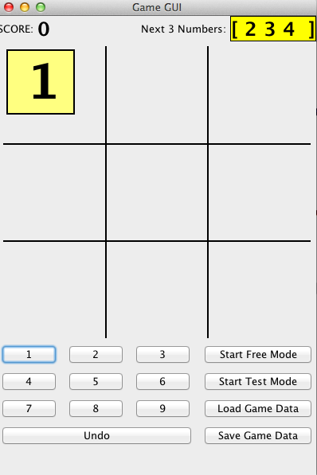

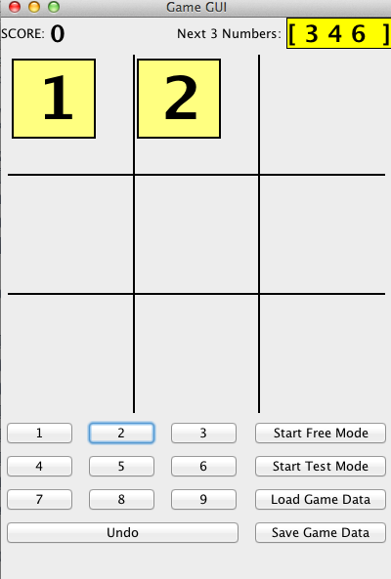

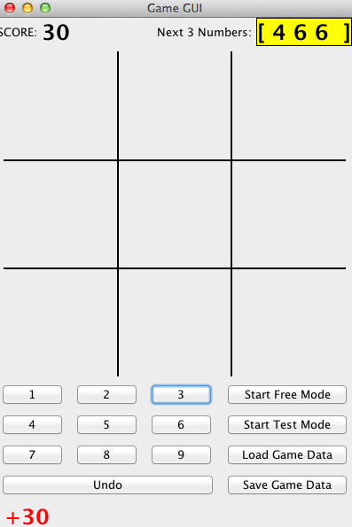

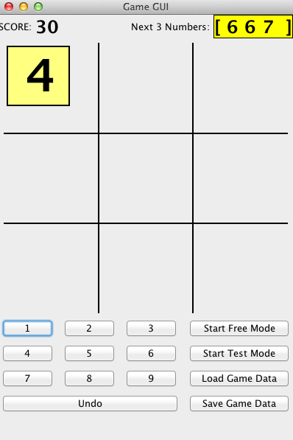

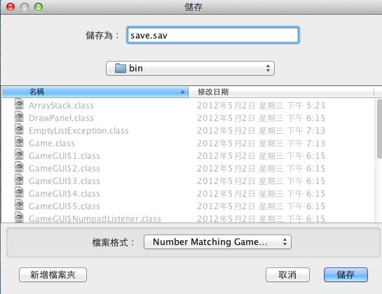

The game is saved, then we start a new game.

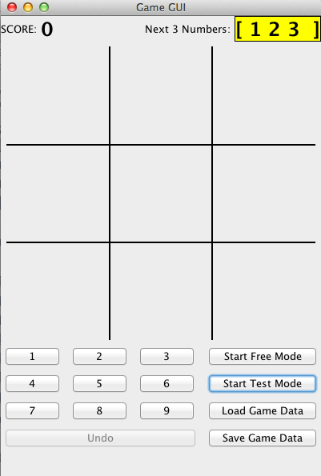

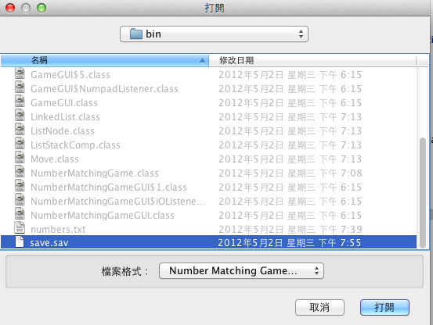

The save will be loaded.

